8.Create a simple cloud web application for student counselling system using any Cloud Service Provider to demonstrate SaaS with the fields of student name, age, address, phone, subjects studied, Year of passing, percentage of marks, domain interest, etc.

STEP1:

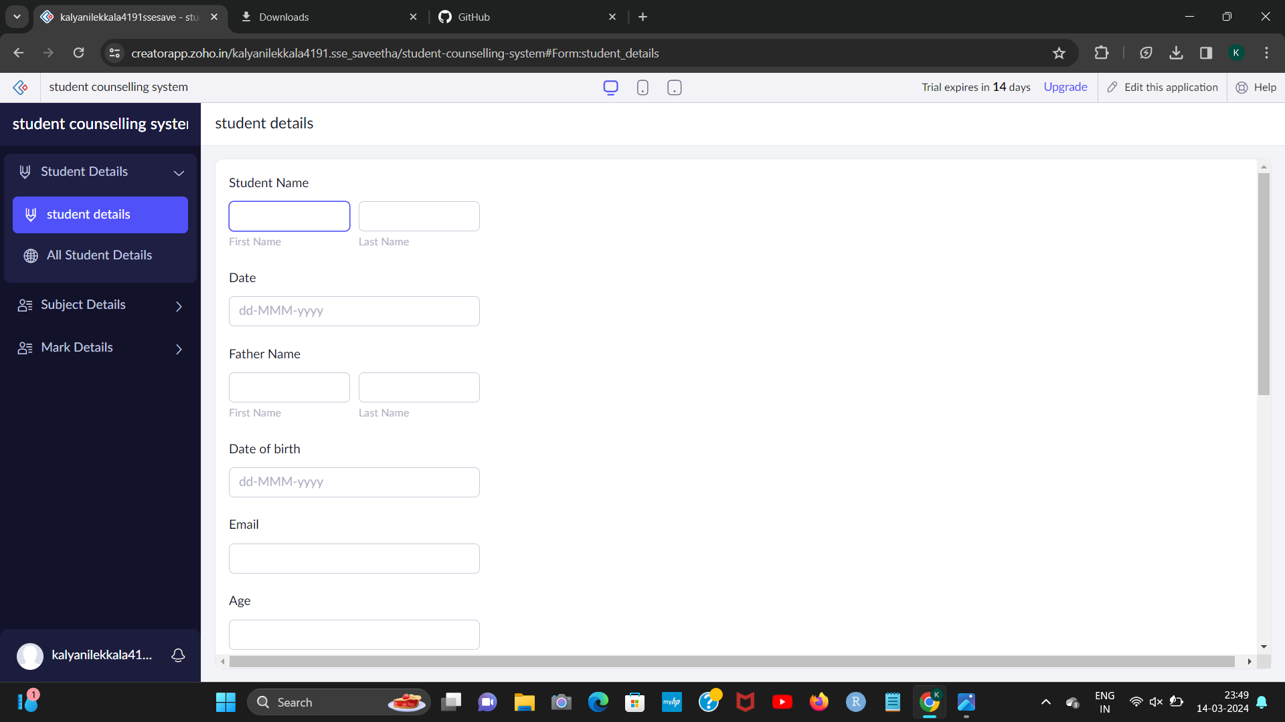

STEP2:

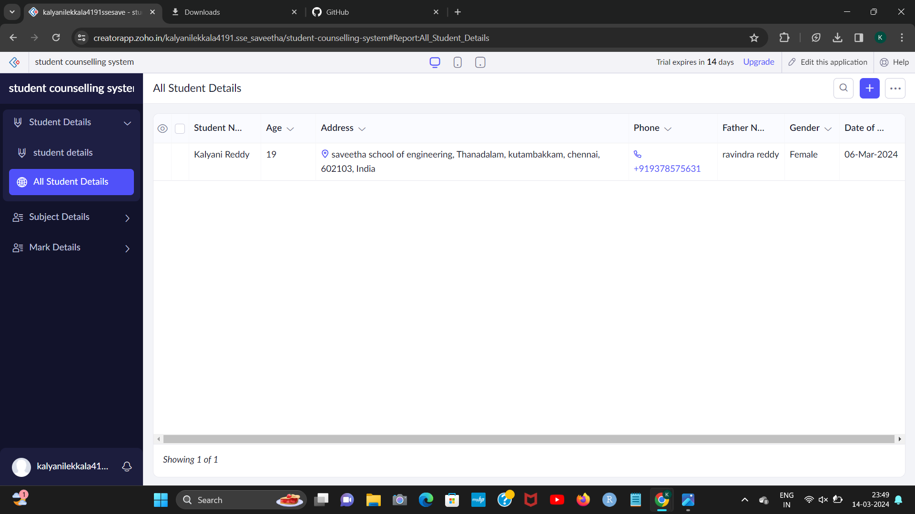

[1]

STEP3:

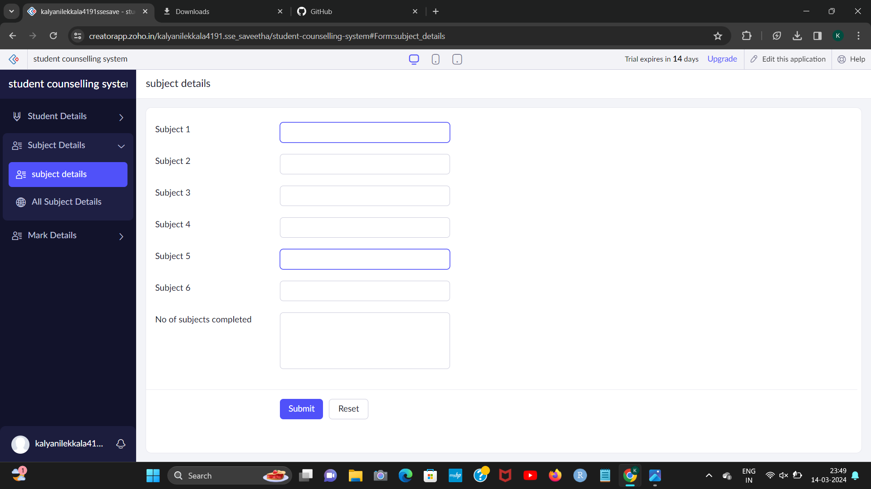STEP4:

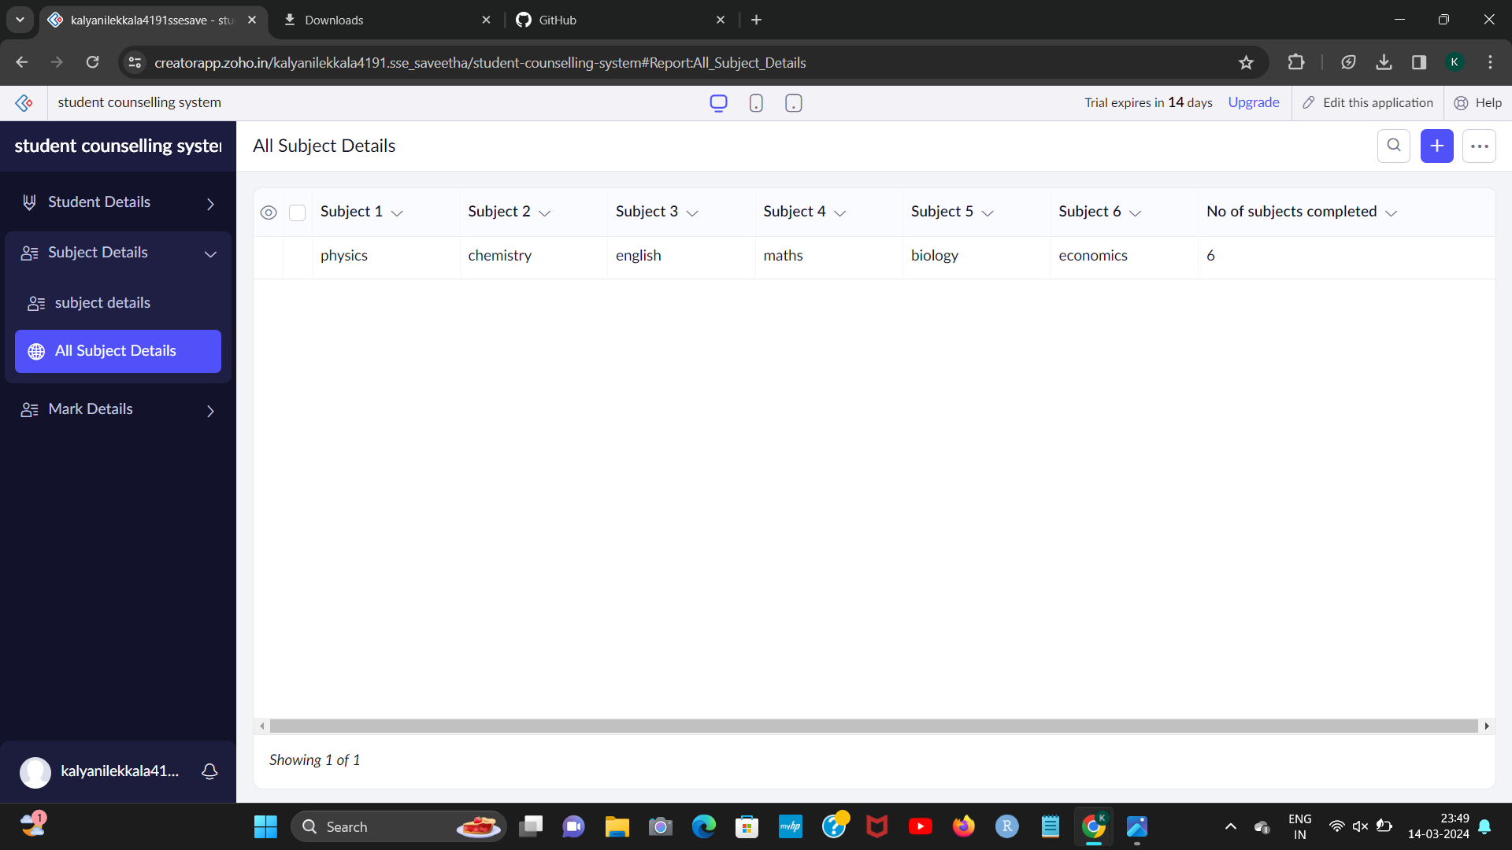

[2]

STEP5:

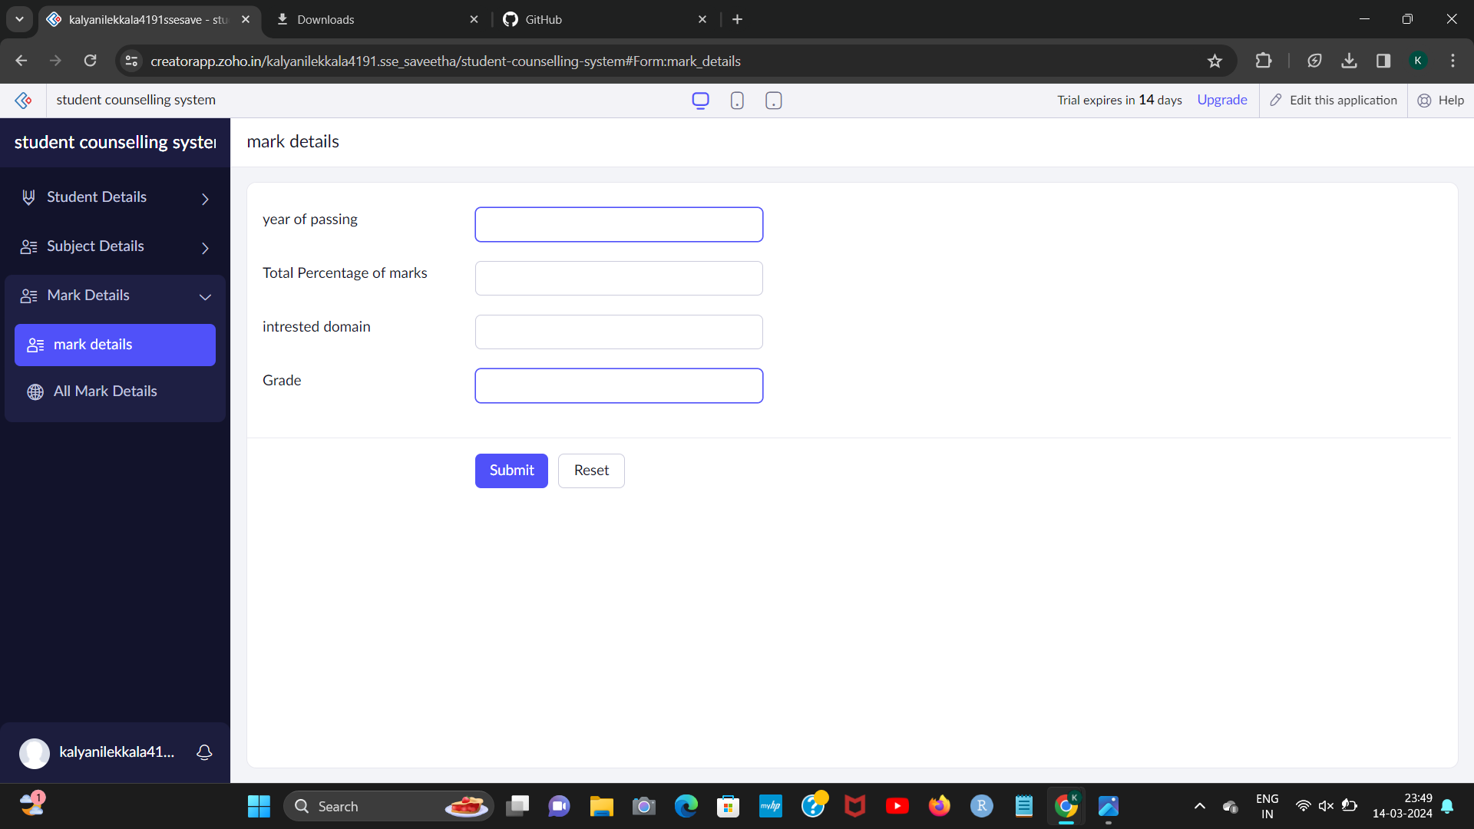STEP6:

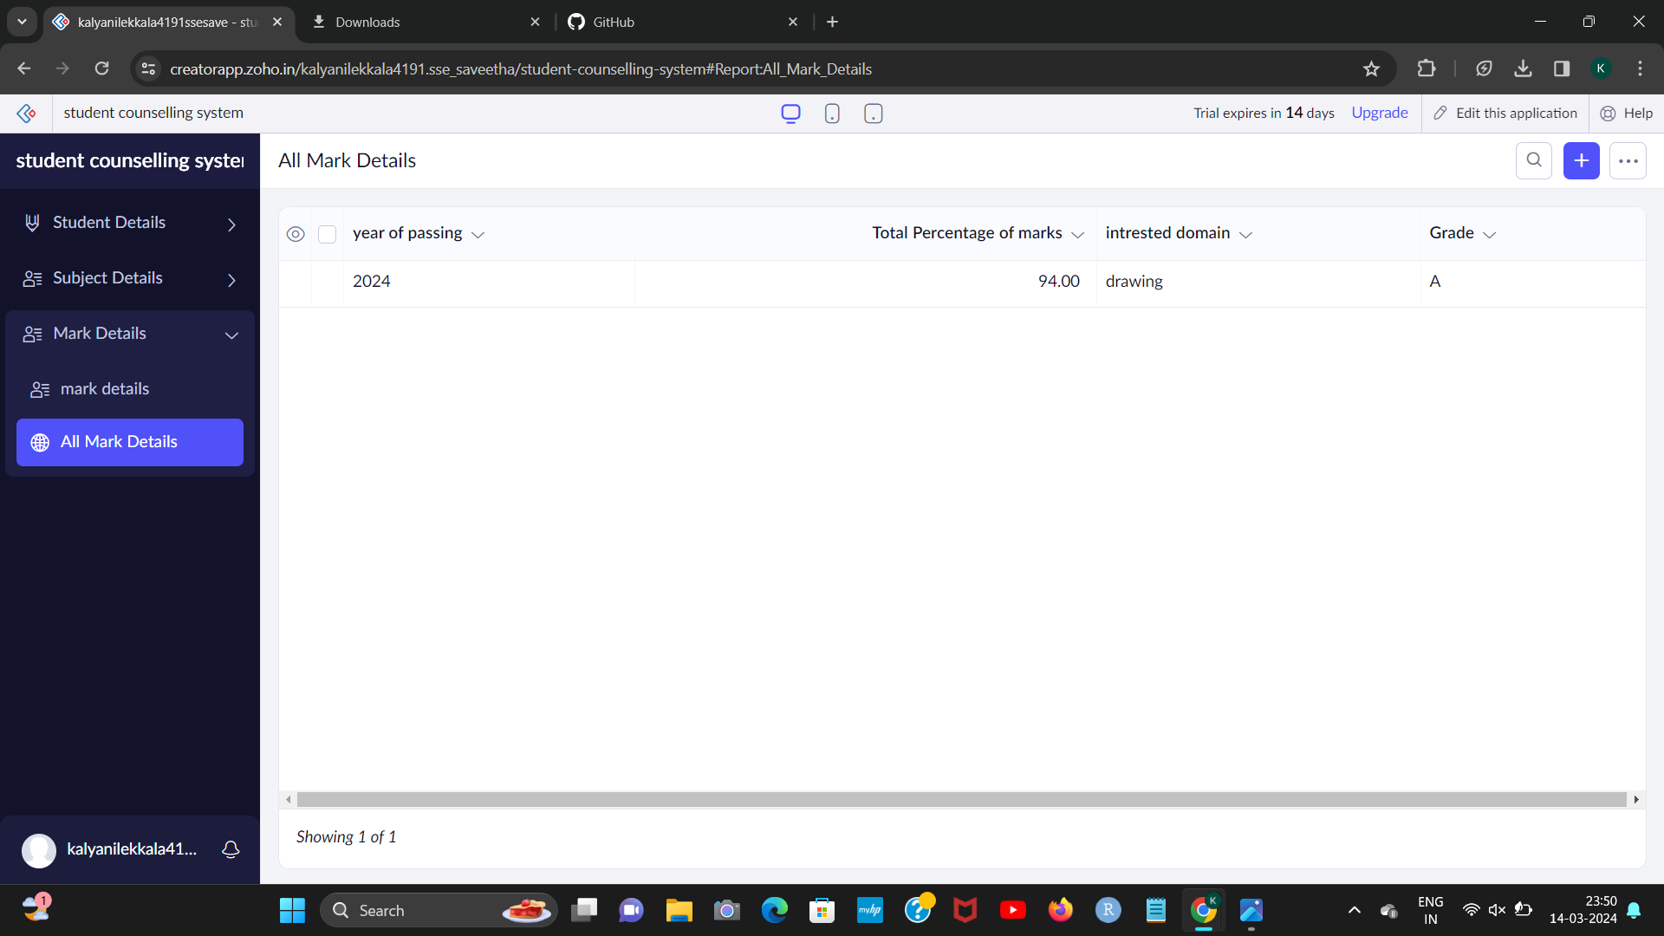

[3]

1. 192224191 L.kalyani
2. 192224191 L.kalyani
3. 192224191 L.kalyani